Planning and Producing FAQs
  - Frequently Asked/Answered Questions

What is a FAQ?

Frequently Asked/Answered Questions
FAQ is an acronym for Frequently Asked Questions or Frequently Answered Questions. A FAQ is a compilation of information in question and answer form, which come from monitoring technical/customer support channels such as email, trouble tickets, and forums, for the most common problems and complaints. Hence the name FAQ (Frequently Asked Questions).
Publish an FAQ page to make questions that nearly everyone would have accessible and easy to follow. Like all user assistance, FAQs should be relevant, concise, accurate and customer focused. Develop your questions and answers keeping your users in mind; and base your FAQs on reality. Take the time to research customer feedback and develop questions that users are actually asking.
The more complex FAQs are often called by other names (for example, Support Center or Help Center), with the actual content following the question and answer format of a FAQ, illustrated in the two complex FAQ examples.

What is a Simple FAQ structure?
A simple FAQ is a short list of questions and answers. No categories, no separate pages, and usually not longer than about 10 questions and answers, more or less.
Example 1: Technical Writer List Frequently Asked Questions (http://www.techwr-l.com/frequently-asked-questions.html)
The Technical Writer List (commonly referred to as Techwr-L) FAQ is a good example of a simple FAQ page. The top 12 questions are listed at the top, with a link on the same page to the question and answer. Each question is shown in a heading style, and the answer is provided in normal body text, so there is a clear segue from one question to the next.
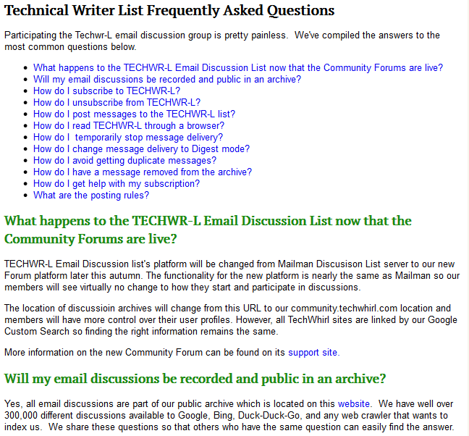

What is a Complex FAQ structure, and when should I use it?
A complex FAQ structure can include categories and multiple pages. For instance, with a retail/commerce site, you’ll see categories such as Contact Us, Shipping and Delivery, Payments, Resources, and Policies. In those categories, you’ll see one or more common questions or topics, which are usually linked to a separate page.

Example #1: B & H Photo and Video (http://www.bhphotovideo.com/find/HelpCenter/helpcenter.jsp)
B & H calls their FAQ a Help Center. They have a navigation tree on the left side, a center column with sections and links, and a right side navigation box that includes the top 10-12 most popular topics. If you click on a link in the center or right side, you go straight to the topic. If you use the navigation tree on the left, you see all topics that relate to a particular section, and then click the link to go to a separate page.
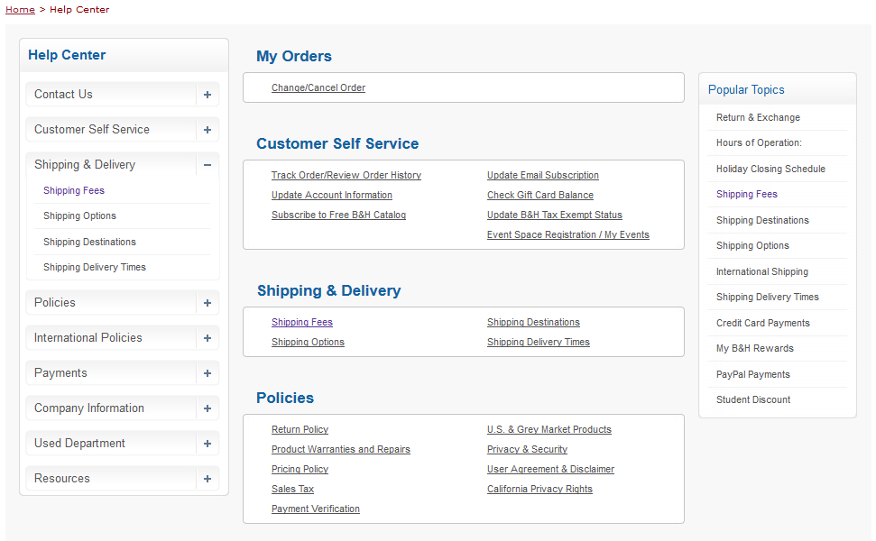

Example #2: Amazon (www.amazon.com/gp/help/customer/display.html)
Amazon uses the complex FAQ structure in their “Help and Customer Service” section. Overall categories (Topics) are shown on the left side, a search bar and popular topics are front and center, and other helpful categories are shown on the right side.
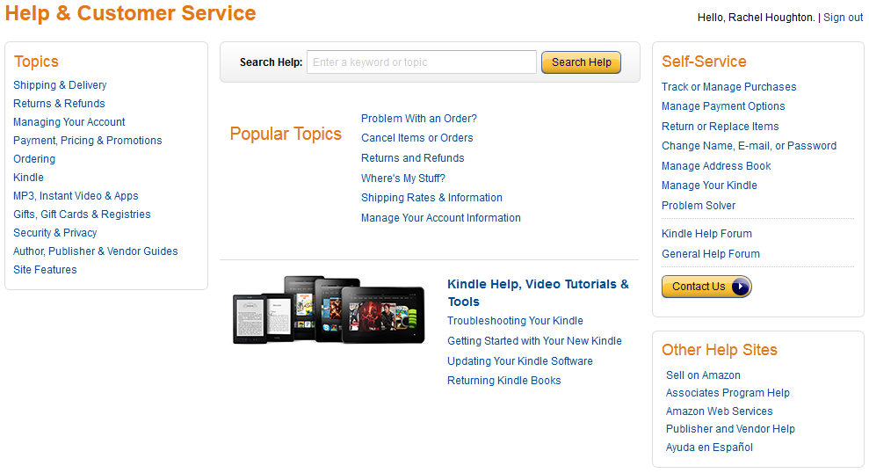

How do I Create a FAQ?

Research
Find out from customer support, sales people, and real customers what are the most commonly asked questions being asked. A customer support call database holds a wealth of information on what customers commonly find confusing and how to resolve problems. But remember that these database entries are from users that will call in (and/or have a maintenance and support agreement). Not all customers will call in, so you’ll need to also check some other channels. Work with your customer support team to get reports on the questions that come in via email or live chat, especially those sent to sales engineers or “catchall” email inboxes (such as help@companyname.com). If the company is using social media, bookmark the customer support handle, and track what people are saying. Some companies make a knowledgebase available to customers with hundreds of articles on a wide range of topics. Get the analytics on these articles to uncover which have the highest hit rate.
If determine that customers have just a few questions, and they don’t seem to lend themselves to categories, use the simple FAQ style. If you support a complex product or suite, reach a wide ranging audience, or have a short product management lifecycle, the Complex FAQ style, where you can group questions into manageable categories.

Simple FAQ style instructions
- Create a list of questions, with input from other teams (marketing, sales and customer support)
- Answer each question concisely. Use your existing content review processes to ensure accuracy.
- Determine the best location for the FAQ in the overall website structure.
  - Common places for the FAQ link:
    - Top-level menu
    - Link on bottom of page
    - Top right corner of website
- Create FAQ page structure.
  - Introductory sentence or paragraph with a short description.
  - List of questions.
    - Create an anchor link to each question.
  - Add each question and answer.
    - Use different formatting for the question and answer
      - Question: Heading style
      - Answer: Body text
  - Build in a feedback mechanism: a section with contact information or a simple form for the customer to ask for more help.
- Create FAQ document and test it in a staging environment.
- Upload the FAQ to the place you designated in step 3.

Complex FAQ style instructions
- Create a list of questions.
- Group each question into general categories.
  - No more than 10-12 categories. Too many leads to confusion for users over which section to use.
  - Use one or two word category names.
- Get feedback on groupings and questions and make modifications to the list and categories as appropriate.
- Answer each question concisely.
- Decide on the structure of the overview/main FAQ page. A three column structure is standard for larger sites, but a two column structure can be used initially if you don’t have “popular topics” to populate a third column. If you have them, work with your web design, ecommerce or digital media team to determine the best layout for your FAQ.
- Decide on the FAQ name.
  - Will you keep FAQ?
  - Will you use Help or Support?
- Determine the best location for the FAQ in the overall website structure.
  - Common places:
    - Top-level menu
    - Link on bottom of page
    - Top right corner of website
- Create the overview/main FAQ page structure.
  - Introductory sentence or paragraph with a short description.
  - Create a navigation tree with category names for one column.
    - Each category should go to a separate landing page. Use the Simple FAQ structure to create the initial content, then review structure as needed.
  - Create a list of categories and questions for one column.
    - List of categories.
    - List of questions.
    - Create a link to each question.
  - Add contact information or a form for the customer to ask a question that is not included in the list.
- Create the category pages and add content.
  - Add each question and answer.
    - Use different formatting for the question and answer
      - Question: Heading style
      - Answer: Body text
  - Link questions to the questions listed in the column create in step 7c.
  - Build in a feedback mechanism: a section with contact information or a simple form for the customer to ask for more help.
- Create the FAQ content, apply the structure, and upload to the place you designated in step 6.

