eLearning Storyboard Template

Company Information

Course Specifics
[List any identifiers, such as course name, module title, numbering scheme, file name/structure, version number, SME name, developer name, outstanding challenges or revision history]
Examples:
Course Name: Getting Started with the User Interface
Module Title: Initial Login Process
File Name: initial_login_v7

Introductory Content
[List the specifics that orient a learner to the course layout, player, assessment modes, objectives. Note: If the software development tool you use has dimension specifics that a developer needs to apply, list those as well. ]

Welcome Slide
[If developers/SMEs are allowed to choose their own image, you can display a placeholder such as the one below. If a chosen stock image is required, just include it in the storyboard.]
Welcome to Module 1:
Initial Login Process
Actions
SME Actions:
- Review, validate, and edit text.
Developer Actions:
- Record audio narration.
- Insert stock image.
- Copy/past text into Notepad to remove formatting. Then copy and paste into the course.
Narration Script:
Welcome to module 1, which covers the initial login process…
Media Files and Locations
Images: sitting_at_desk.png, stored in Basecamp | Audio: welcome.mp4, stored in Basecamp | Video: N/A | Interaction: N/A

Introduction Slide
[Provide any introductory information to the learners so they can understand more about this particular module, course, or lesson.]

Initial Login Process
[Intro text]
- Lesson 1:
- Lesson 2:
- Lesson 3:
- Lesson 4:

Actions
SME Actions:

Developer Actions:

Narration Script:

Media Files and Locations
Images: | Audio: | Video: | Interaction:

Course Tour/Navigation Details
[If there are navigation elements, such as buttons to click, or other elements that could confuse the learners, provide a screen shot and/or screen recording to help them navigate.]
Course Tour
To navigate through this course, click the Back and Next buttons. To view upcoming content or navigate to another section, click the Menu button.
Watch or try it out yourself by clicking the buttons below.

Actions
SME Actions:

Developer Actions:

Narration Script:

Media Files and Locations
Images: course_tour.png | Audio: course_tour.mp4 | Video: course_tour.mp4 | Interaction: course_tour.udc

Intended Learning Outcomes
[Whether you want to call them learning outcomes, objectives, goals, or lesson plans, you should provide a roadmap so your learners have an idea where you are going and your developers know how to get them there. Also list any standard/stock/reused copy.]
Objectives
At the end of this module, you will be able to:
- Access the online system
- Log in to your personal account
- Find the available help resources

Actions
SME Actions:

Developer Actions:

Narration Script:

Media Files and Locations
Images: | Audio: | Video: | Interaction:

Course/Module Content
[This section forms the bulk of the course material, where the specific learning for the module/lesson happens.]

Static Content
[Use this area for content that is just read and reviewed rather than containing interactive elements.]
Process Flow
This process diagram shows the general workflow for logging into the system. You will be able to practice logging in.

Actions
SME Actions:

Developer Actions:

Narration Script:

Media Files and Locations
Images: | Audio: | Video: N/A | Interaction: N/A

Simulation or Demonstration
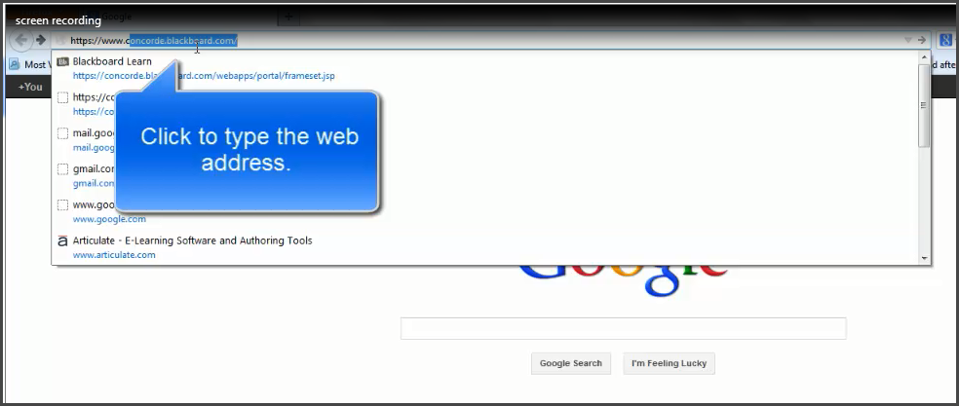
[When building material based on screen recordings, that the user is to watch or try, list the actions the user needs to take along with design elements, such as "Watch" and "Try" buttons, to give the feel for the process steps).
How to Log In
Click the buttons to watch or try the simulation or demonstration on how to log in to the system.

Actions
SME Actions:

Developer Actions:
- Capture each step for the learner in the simulation/demo.
- Create instructions to walk the learner through how to watch and try.
- Record the audio narration.
Narration Script:

Media Files and Locations
Images: | Audio: | Video: | Interaction:

Interaction
[When building material that is more interactive, list the actions the user needs to take along with design elements, such as "Click here" buttons, to give the feel of how the design and interactive elements work together).
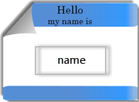
Please tell us your name!
Click the nametag and add your name. Then click Next to save your information.
This will create a personalized certificate for you when you complete the course.

Actions
SME Actions:
- Review the instructions and ensure they are captured correctly.
Developer Actions:
- Record screens for the interaction and save the file as shown below.
- Record the audio narration.
Narration Script:

Media Files and Locations
Images: | Audio: | Video: N/A | Interaction: name_entry

Video
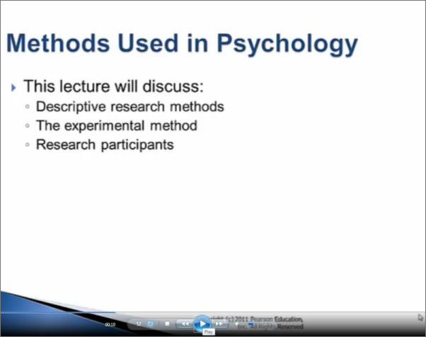
[When including videos, provide a description, the intended learning outcome, and any actions the learner needs to take.]
Psychology Methods
Please click the button below to review a video on the methods used to research in psychology.

Actions
SME Actions:
- Review the instructions and ensure they are captured correctly.
Developer Actions:
- Record the video and narration.
Narration Script:

Media Files and Locations
Images: methods_screen1.png | Audio: | Video: N/A | Interaction: methods_of_psych.mp4

Quiz/Assessment Content

Lesson 1 Quiz
This quiz will test your practical skills based on the learning in lesson 1.

Question stem:
Answers:
A.
B.
C.
D.
Actions
SME Actions:
- Review the instructions and ensure they are captured correctly.
Developer Actions:
- Record the video and narration.
- Create the quiz items shown above.
Narration Script:

Media Files and Locations
Images: | Audio: | Video: N/A | Interaction:

